**Green school update**

**We are currently working on our Biodiversity Green Flag.**

Last year Ms Cronin and Ms Keane's class did a fantastic set of experiments for Science Blast. Since then we have designated the area between the new building and the tennis courts are a No Mow Zone. This will increase the Biodiversity of plant and animal life in the school. The slopping area behind 4th and 5th class is also being allowed become a wilded area.

Recently we have put bird feeders up around the school and planted Daffodils in the No Mow Zone. A Large bug hotel has allow been put in place to help the insects and pollinators in the area.

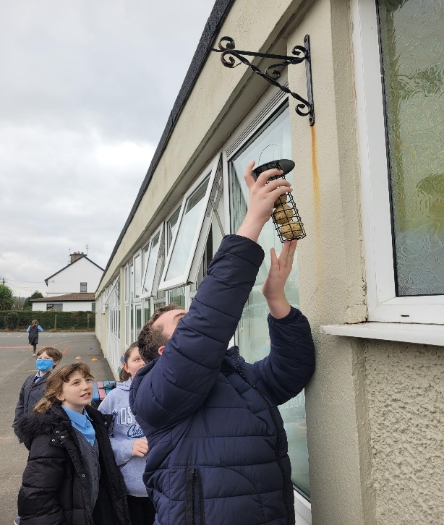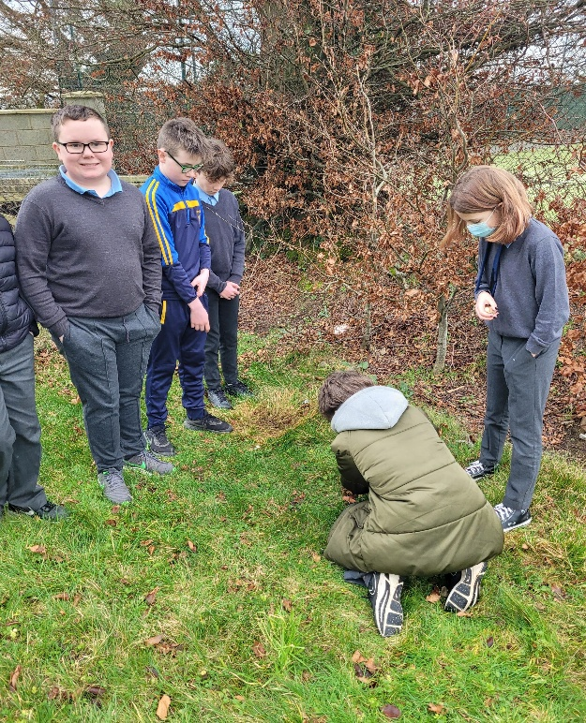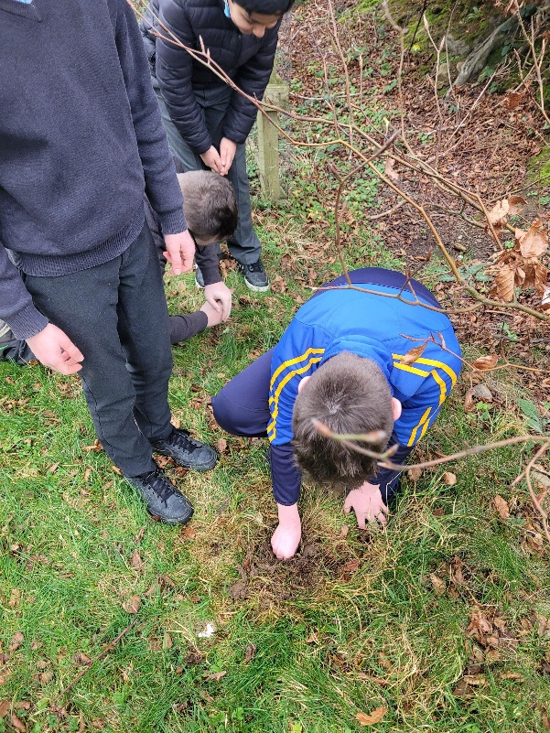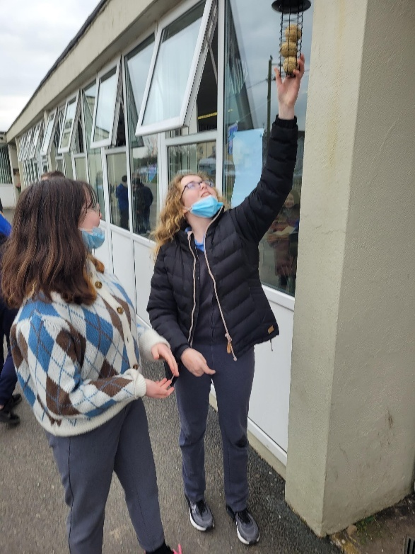

6th Class are also participating in 2 citizen science surveys.

.For January and February we are doing  the Irish Garden Bird Survey is you would like to participate the link is here. <https://birdwatchireland.ie/our-work/surveys-research/research-surveys/irish-garden-bird-survey/>

We also had a visit to 5th and 6th class from Aisling Natoff explaining about the importance of Biodiversity which was very informative.

# Over the coming months we are also going to participate in the National Biodiversity Backyard Biodiversity survey . The link is here if you would like to get involved. <https://biodiversityireland.ie/surveys/backyard-biodiversity/>