Green Flag Poster Competition results.
The Posters were of a very high standard and it was a very tough decision to choose between the posters.
5th class selected the top posters in groups then the whole class voted for who came first, second and third in each class. There were some very tight margins.
Below are the 1st, 2nd and 3rd place results for each class. The order of the pictures in each photo is not reflective of 1st ,2nd or 3rd place.
Prizes will be given out when we are back in school.

Junior infants – Ms Murphy; -
1st - Kate
2nd -Caityln
3rd - Clara
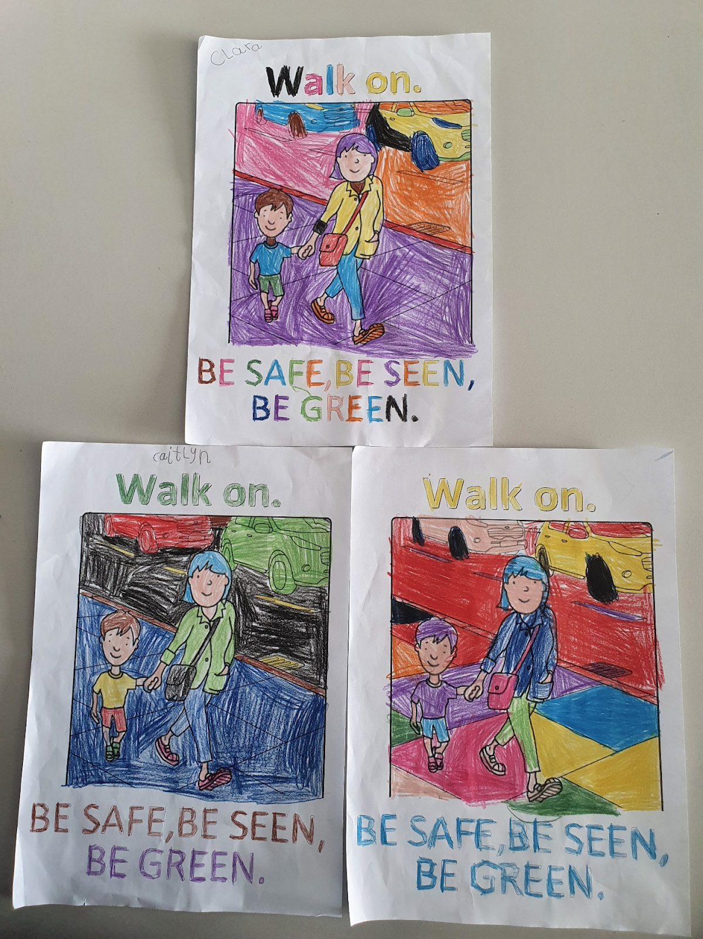

Senior Infants - Ms Murphy’s Senior Infants - Ms. O’ Sullivan

1st - Adam 1st - Kayla
2nd -Gwen 2nd - Katie
3rd - Padraig 3rd - Sadhbh
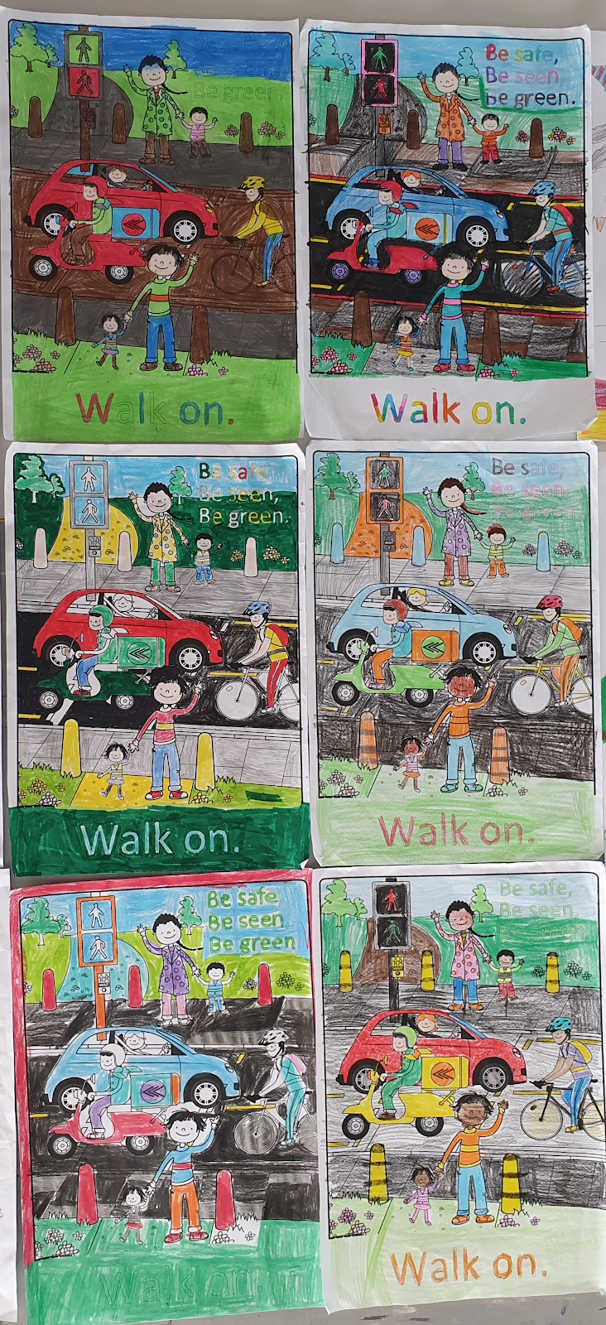

1st Class - Mr. Dunne
1st - Domhnall
2nd -Aoife
3rd -Mel
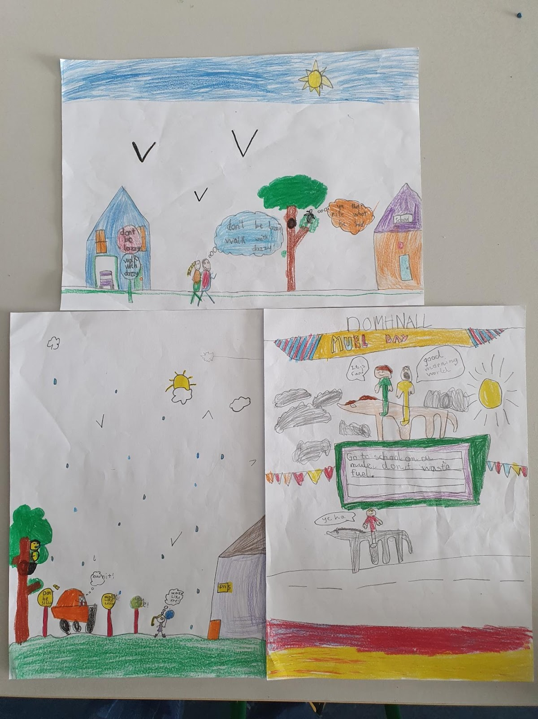
2nd Classb - Ms O’ Sullivan
1st - ????
2nd - Maeve
3rd - Tiarna
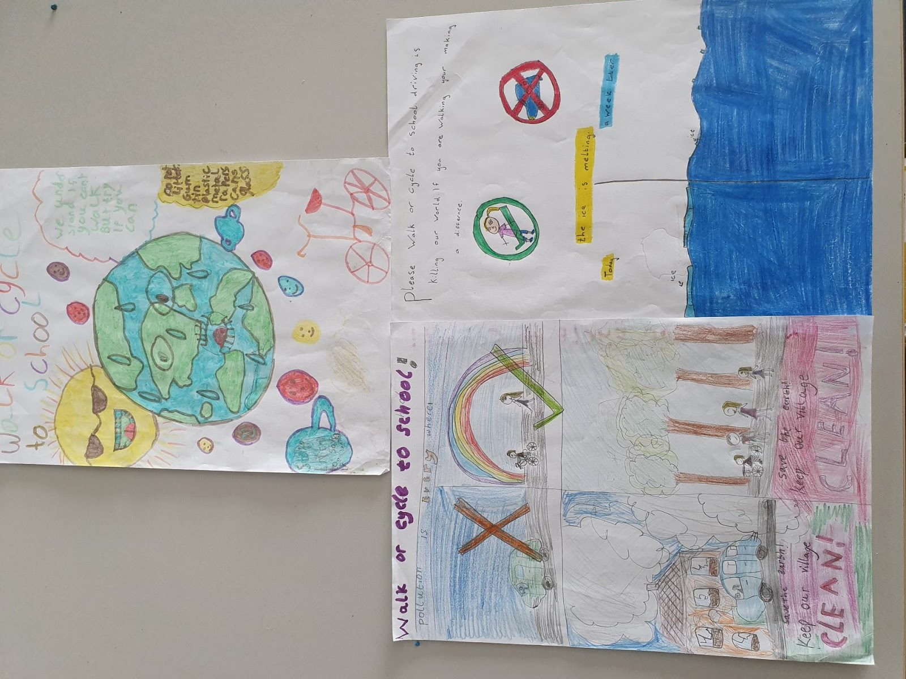
3rd Class Ms Herlihy/ Ms Hegarty
1st - Leah
2nd - Brendan
3rd - Sophia D.L.
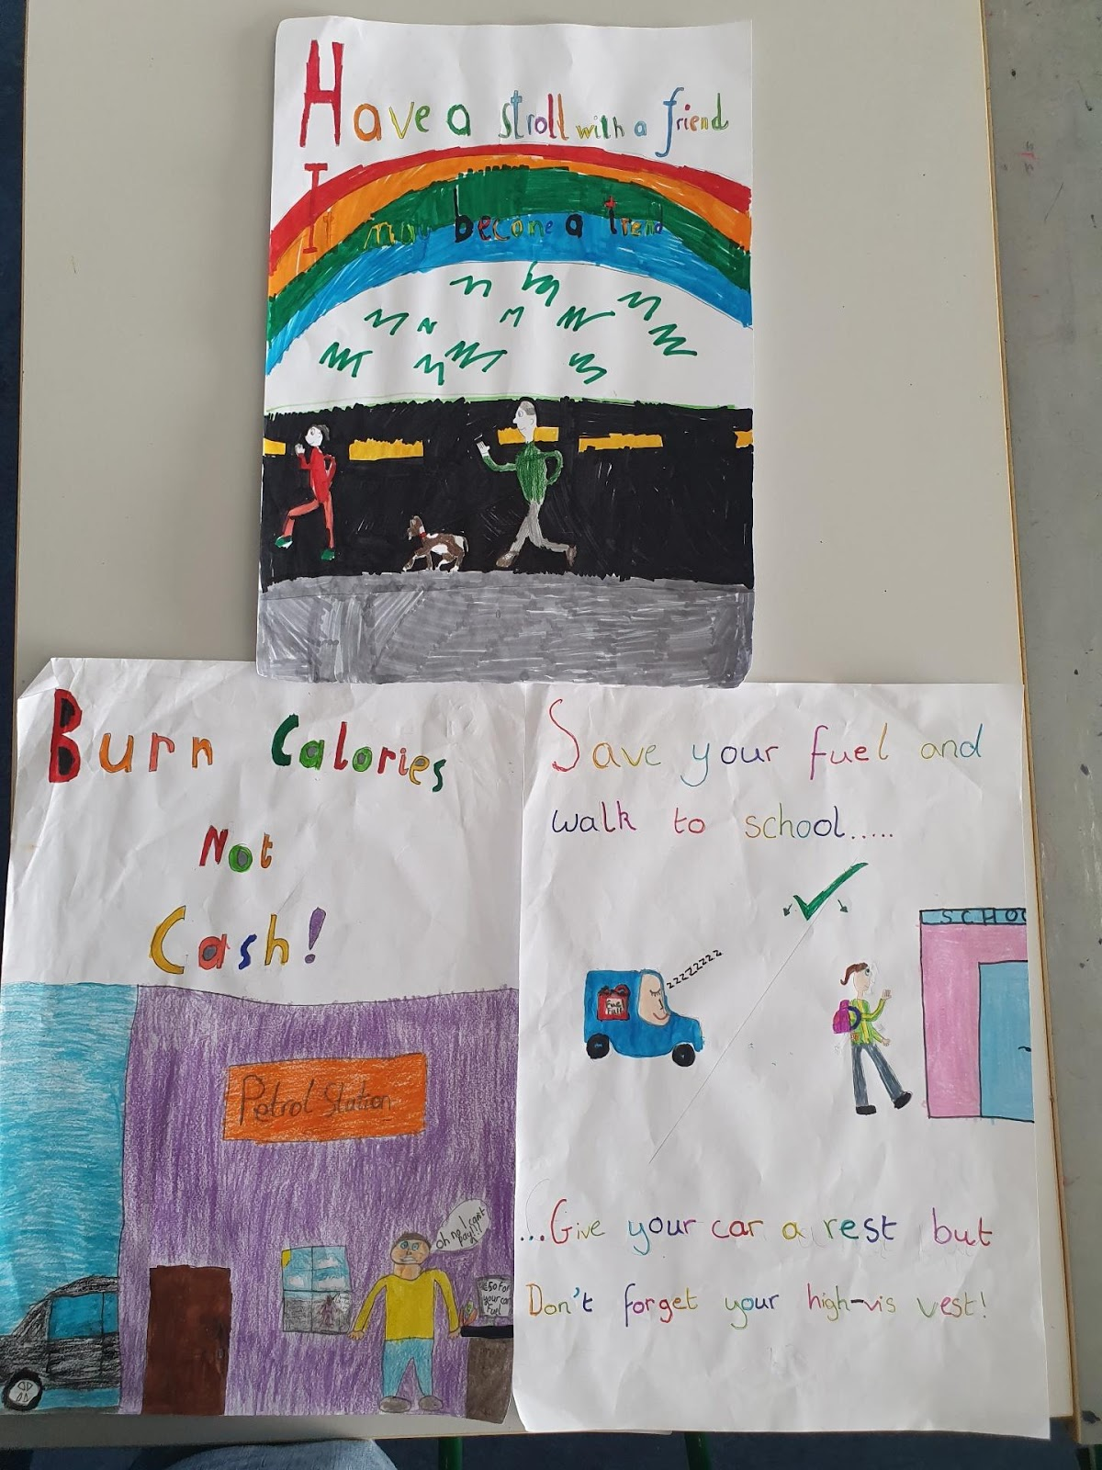
4th Class - Ms Murphy
1st - Martina
2nd -Rebecca
3rd -Logan
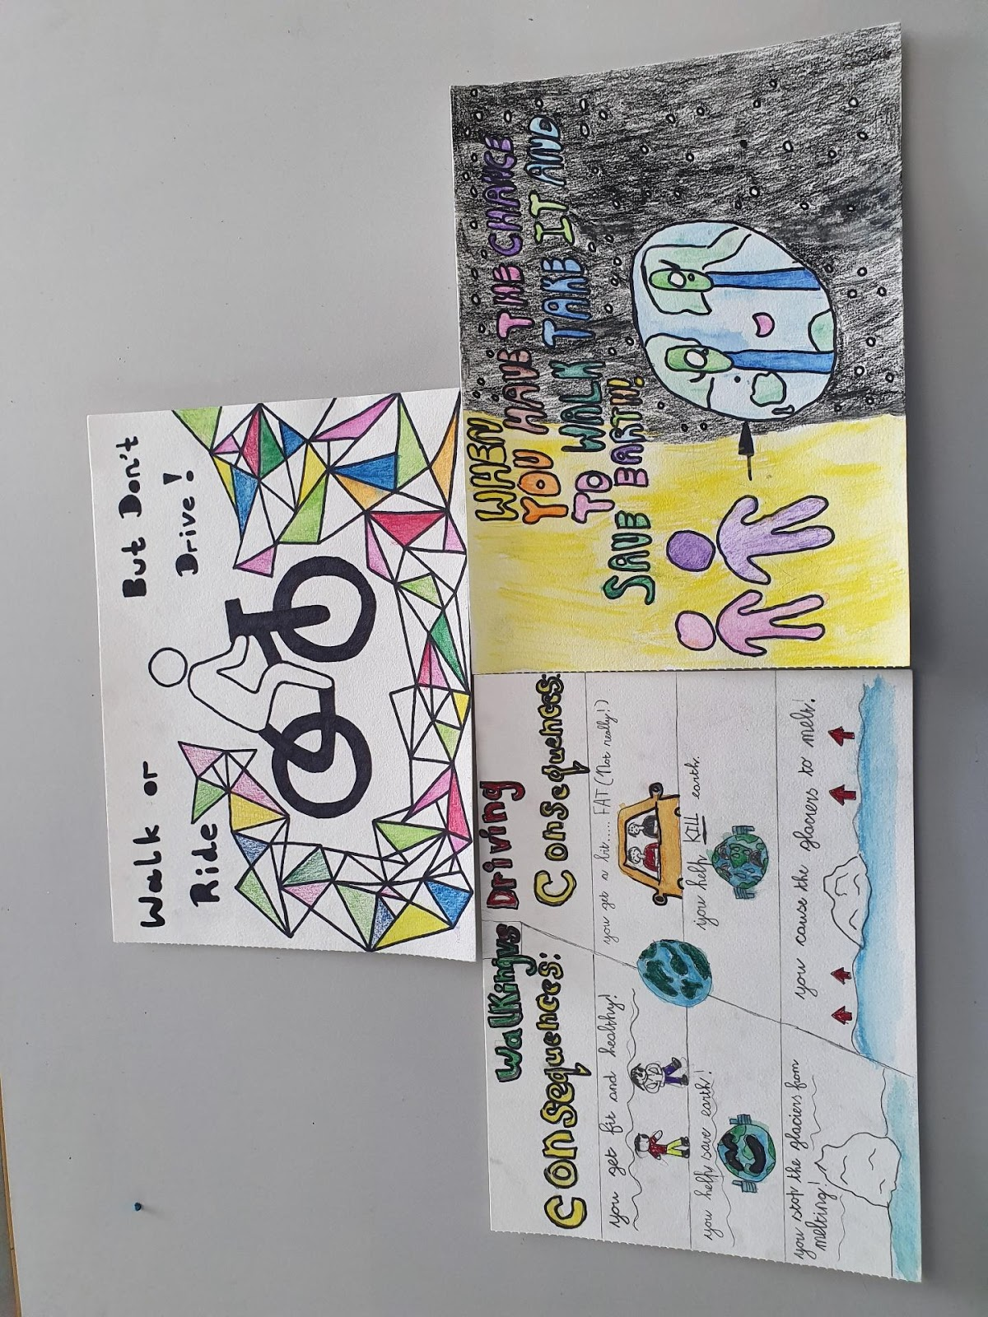

6th Class - Ms O Riordan
1st - Lily
2nd - Aoibhinn
3rd - Aine O’ Rourke
