Access to Books Online
Folens
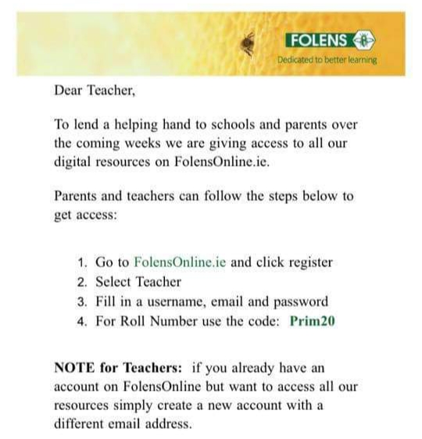

CJ Fallon
As of today, in response to the COVID-19 crisis, teachers, parents and pupils can access the online versions of all CJ Fallon books for free. Simply click here and filter to your required title.
If you would prefer to access these directly, visit http://my.cjfallon.ie, click 'Student Resources', then filter to the title you require, making sure 'Online Book' is selected under 'Resources'.

Edco
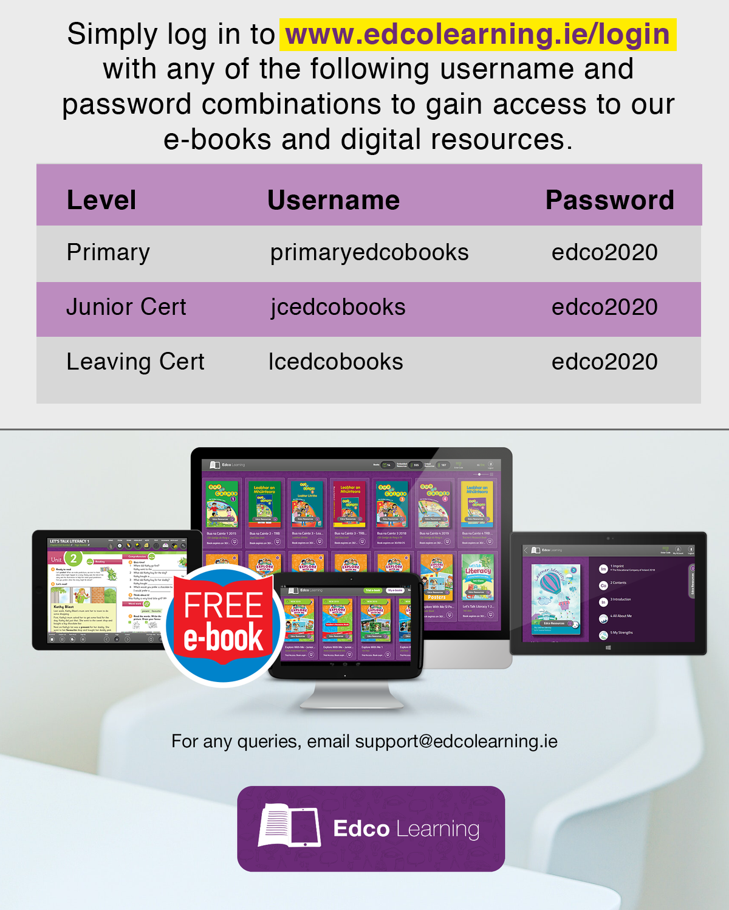

Some other online activities
Dulingo : A free language app. Children can do some oral Irish or maybe dabble with a new language French, Spanish maybe even Chinese.
Science Foundation Ireland
https://www.sfi.ie/engagement/discover-primary-science-and-maths/activities-search/ : a selection of science experiments most of which can be done with basic household equipment
Amazon Books: Now free to stream. A host of books and audio stories
Reading eggs: Three different reading programmes based on children’s ages
www.multiplication.com Loads of multiplication games for 3rd Class upwards
Futa Fata are doing a Scéal an Lae / story with animation every day. Can be found on Youtube or on their Facebook page
PE with Joe: Joe Wicks, the Body Coach, is holding daily P.E. lessons on Youtube live at 9.00a.m. or can be accessed any time after that, a great activity for any wet days

